**SOIL CONSERVATION**

Conservation: to preserve, protect, and practice the wise use of natural resources (soil).

Soil Erosion: soil that is carried away by water, wind, and mass wasting (gravity).

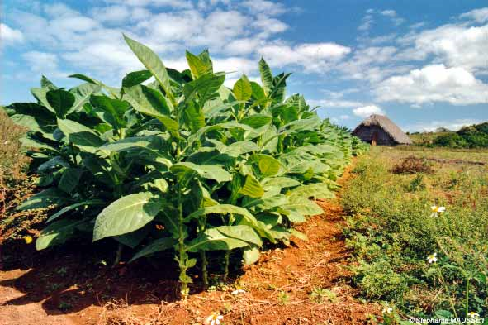

Strip planting

Strip cropping: Planting tall, medium, and short crops in ordered rows. The tall plants help reduce wind erosion while the short plants create a ground cover.

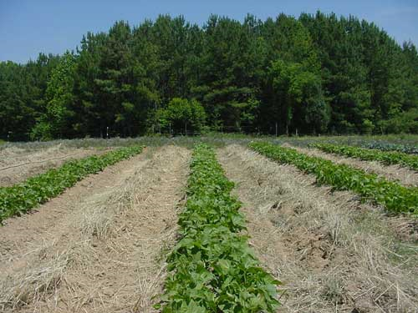

Cover Crops

Cover crop: keeping plants on bare farmland during winter. Reduces wind and water erosion. Decomposing plants provide nutrients to the soil.

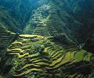

Terrace farming

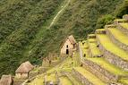

1. Terracing: step-like ridges built on steep slopes. Terracing prevents mass wasting and water erosion.

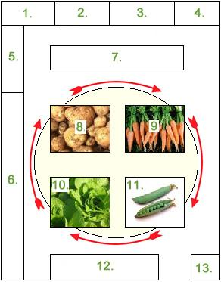

Crop Rotation

Crop rotation: alternating crops yearly that are planted. Crop rotation helps replace nutrients that previous crops have depleted (taken out).

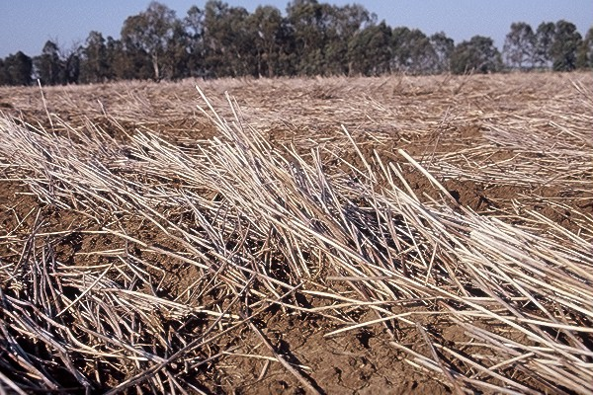

No-till/Stubble Planting

No-till/stubble planting: Planting crops in the stubble of the previous year’s crop. Decomposing stubble adds nutrients and protects new seedlings from water and wind erosion.

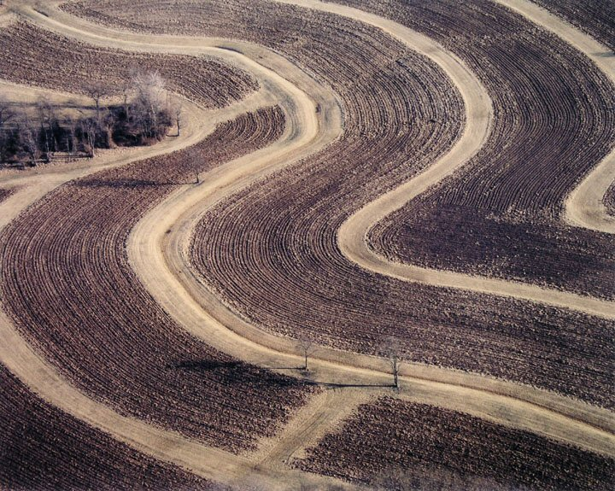

Contour Plowing

Contour plowing: planting rows horizontally around hills instead of up and down. Contour plowing reduces water erosion.

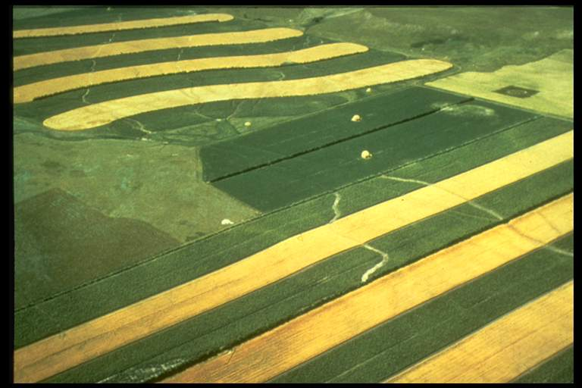

Strip Cropping

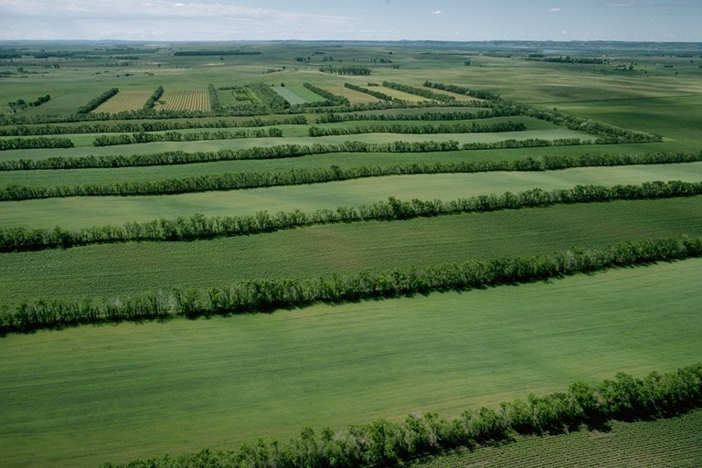

Windbreak

Windbreak/shelter belt: rows of trees planted in between sections of farmland. Windbreak reduces wind erosion by deflecting the wind upward.

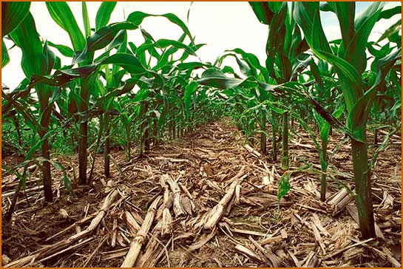

No-till farming

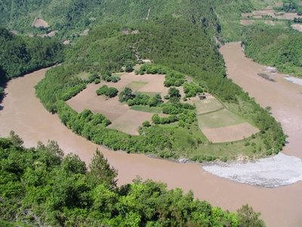

Contour Plowing